**PUBLIC TRANSPORT**

**OPTIMIZATION**

**Phase 1: Project Definition and Design Thinking**

**Project Definition:**

**Real-Time Information:**

* Provide real-time information such as traffic conditions, vehicle locations, estimated time of arrival and service status.
* Real-time updates on traffic flow, incidents, and delays.
* Live tracking of vehicles to inform passengers about their current location.

**Arrival Time Prediction:**

* Develop an accurate system that predicts the arrival times of public transportation vehicles at stops or stations.
* Integration with mobile apps and displays at stations to showcase predicted arrival times for different transportation modes.

**Ridership Monitoring:**

* Monitor and analyze ridership (number passengers in travel) to optimize transportation services and resources based on demand.
* Notify all the information about ridership to nearby stations.

**Enhanced Public Transportation Services:**

* Integration of user feedback mechanisms to collect suggestions and complaints.
* Implementation of features like seat availability indicators, priority seating for specific groups, and improved accessibility.

**IoT Sensor Design:**

* Deploying IoT sensors in public transportation vehicles can help improve safety, efficiency, and passenger compatibility.

**Sensor Placement:**

* **Doorways (Entrance / Exit):**

To count and analyze passengers' ridership and notify to the

nearby station using **IR Sensor, Ultrasonic Sensor, Motion**

**Sensor.**

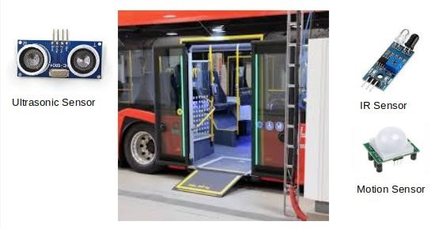

* **Seating Areas:**

To check how many empty spaces are available in the public vehicles using Compression Load Cells, Vibration Sensor place under the **seats.**

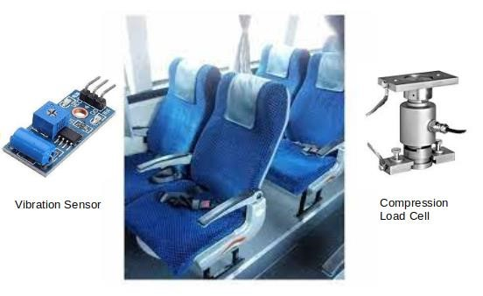

**GPS & RFID:**

Provide real-time information about various aspects of the transportation system, such as traffic conditions, vehicle live locations, predicts the arrival times using **GPS Devices** and RFID Tags placed on roof of the Bus or front of the Bus.

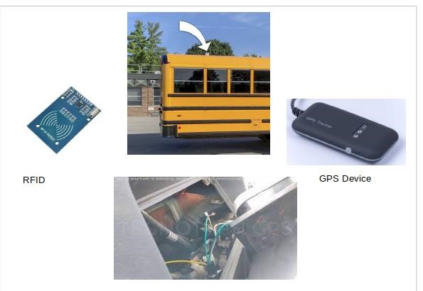

**Real-Time Transit Information Platform:**

* **Integration**  **with Mapping Services:**

Incorporate maps and geospatial data into your platform to display transit routes, vehicle positions, and stop locations. Consider using mapping APIs such as Google Maps or Map box and display in each station.

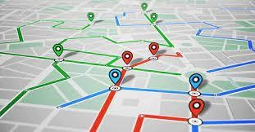

**Accessibility and Mobile Responsiveness:**

Ensure that your platform is accessible to users with disabilities by following web accessibility guidelines (e.g., WCAG).

Optimize the platform for mobile devices to reach a broader passenger

* **Connectivity:**

Public Vehicles connect to nearby wireless stations (i.e., Base stations, WLAN) and displays details about ridership, seat availability, Bus Routings and arrival Timings to every passenger.

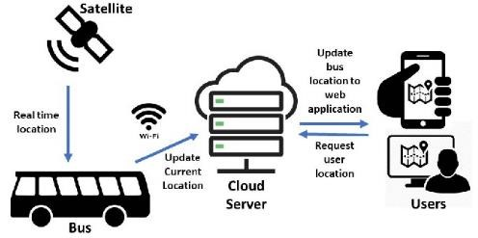

* **Integration Approach:**

⦁Data Collecting using IoT sensor:

⦁It determines how IoT Sensors send data to the real time transit. All the information's are sent to web using Hardware like GSM Module and ESP8266, etc.

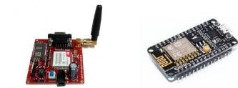

**Data Aggregation & Processing:**

In some cases, IoT sensors may have limited processing capabilities to aggregate and preprocess data locally. However, more complex processing is often performed on a dedicated gateway device or in the cloud.

* **Data Transmission:**

⦁Cellular Networks:

Sensors can transmit data over 3G,4G,5G networks. This is a common choice for sensors on moving vehicles.

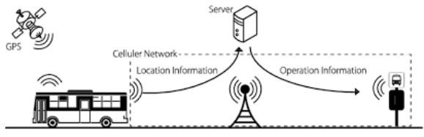

* **Wi-Fi or LoRaWAN:**

⦁Sensors located in station or stop to transmit data over local Wi-Fi.

⦁Low-power, low range wireless area networks can be used in sensor remote locations.

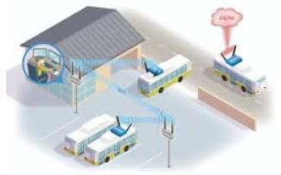

**Protocols used in Data Transmission:**

⦁MQTT (Message Queuing Telemetry Transport): MQTT is a standards-based messaging protocol, or set of rules, used for machine-to-machine communication. Smart sensors, wearables, and other Internet of Things (IoT) devices typically must transmit and receive data over a resource-constrained network with limited bandwidth.

⦁CoAP (The Constrained Application Protocol): It is also a client- server protocol designed for the Internet of Things. It too targets constrained devices but is modeled on the World Wide Web of resources (URIs) and it uses a binary header format, a smaller message size, and a simpler request-response mode.

⦁Advanced Message Queuing Protocol (AMQP): It is an open source published standard for asynchronous messaging by wire. AMQP enables encrypted and interoperable messaging between organizations and applications. The protocol is used in client/server messaging and in IoT device management.

⦁Simple Network Management Protocol (SNMP): is an internet standard protocol used to monitor and manage network devices connected over an IP. SNMP is used for communication between routers, switches, firewalls, load balances, servers, CCTV cameras and wireless devices.

⦁Hypertext Transfer Protocol Secure (HTTPS) : is a protocol that secures communication and data transfer between a user's web browser and a website. HTTPS is the secure version of HTTP. The protocol protects users against eavesdroppers and man-in-the- middle attacks.

By THIRUMALAI.V